

**Operating System**

**Lab # 08**

**Name: Zainab Bibi**

**Sap Id: 46462**

**Batch: BSCS 5thsemester**

**Submitted to: Mam Kausar**

**Mkdir:**

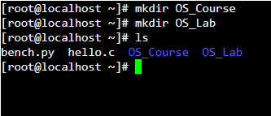

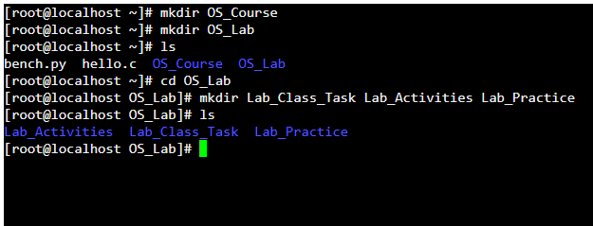

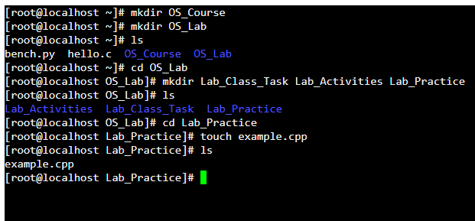



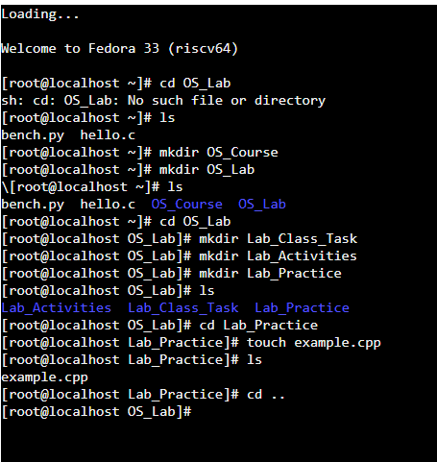

**Absolute Path:**

The complete path from the root directory, always starting with /.

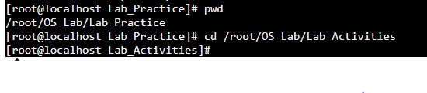

**Relative Path:**

The path based on our current location, it doesn’t start with /.

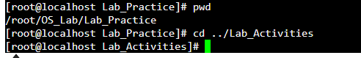

**Make following directory:**

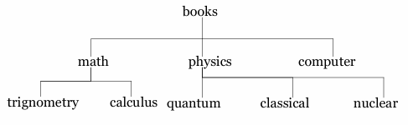

**Solution:**

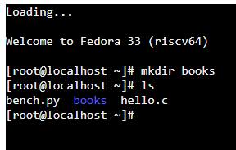

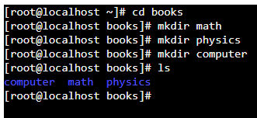

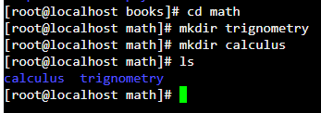

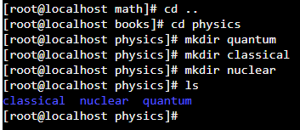

1. **mkdir: Create a new directory**

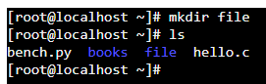

1. **rmdir: Remove an empty directory**

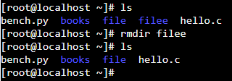

1. **cd: Change directory**

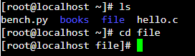

1. **cd/: Go to home directory**

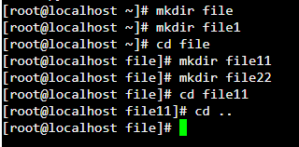

1. **pwd: Present working directory**



1. **ls: List directory contents**

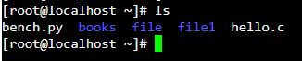

1. **mv: Move or rename files and directories**

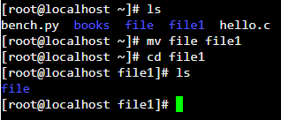

1. **cp -r: Copy files and directories**

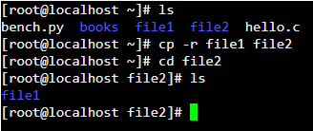

1. **rm -r: Remove directories (if directory is not empty)**

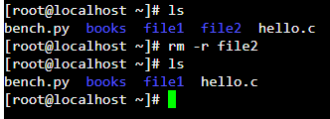

1. **ls -r: show list of directories in reverse**

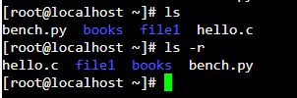

1. **ls -a: show hidden files also of that directory**

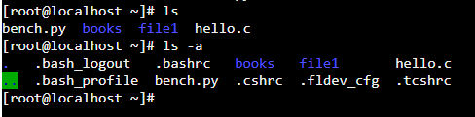

1. **ls -l: show all details list of files**

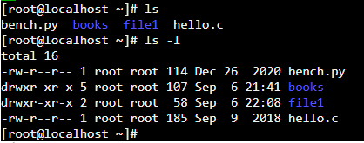

1. **touch: to create an empty file**

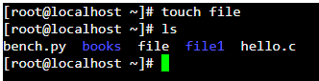

1. **cat > file: create file and gave us space to write data in that file**

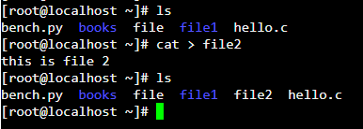

1. **cat file: read data from that file**

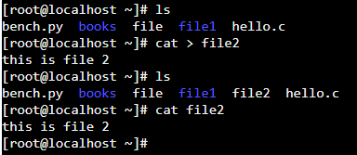

**Symbolic method:**

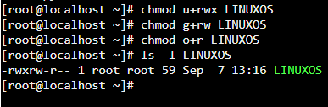

**Numeric method:**

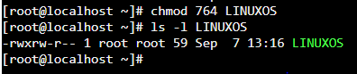

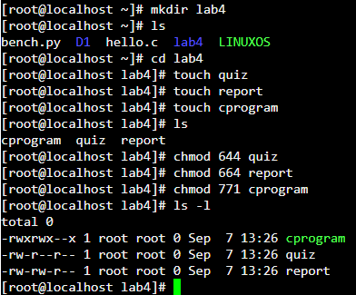

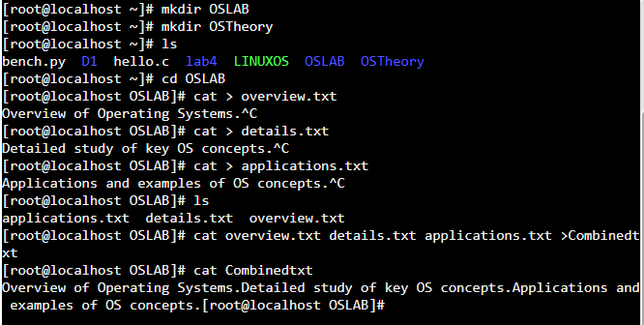

**Use of Touch:**

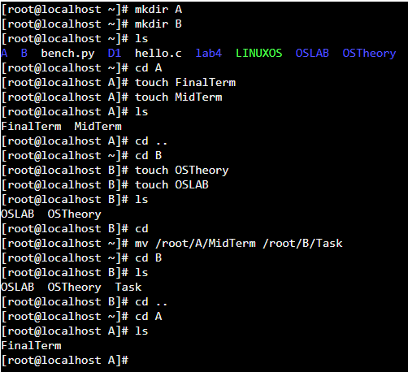

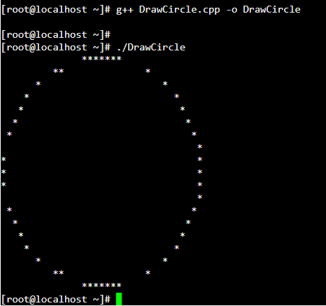

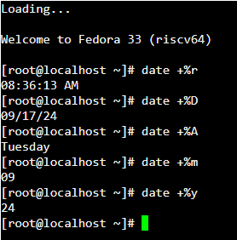

**Hours and Minutes:**



**Date in years:**



**Complete Time:**



**Yesterday date:**



**Tomorrow date:**



**10 days ago date:**



**Calendar:**

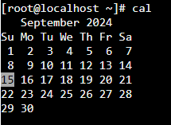

**Calendar of specific month:**

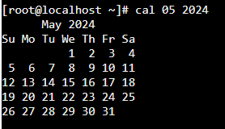

**Welcoming message:**

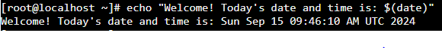

**Clear:**



**Reverse a file:**

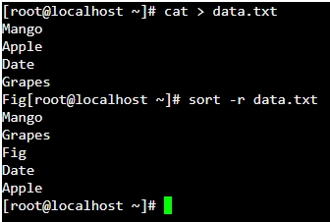

**THE END**

**Lab Task**

**Note:** Include screenshots, required to illustrate your explanation for all Questions.

Q1: Can you provide a detailed guide for each Linux command that includes screenshots and different examples beyond what has been taught? Additionally, can you identify each symbol and explain why it is used? Please explain each step one by one for every command.